Day 24 - 8th August- 113195064 - Bondili Bhavya Charitha
TASK:1
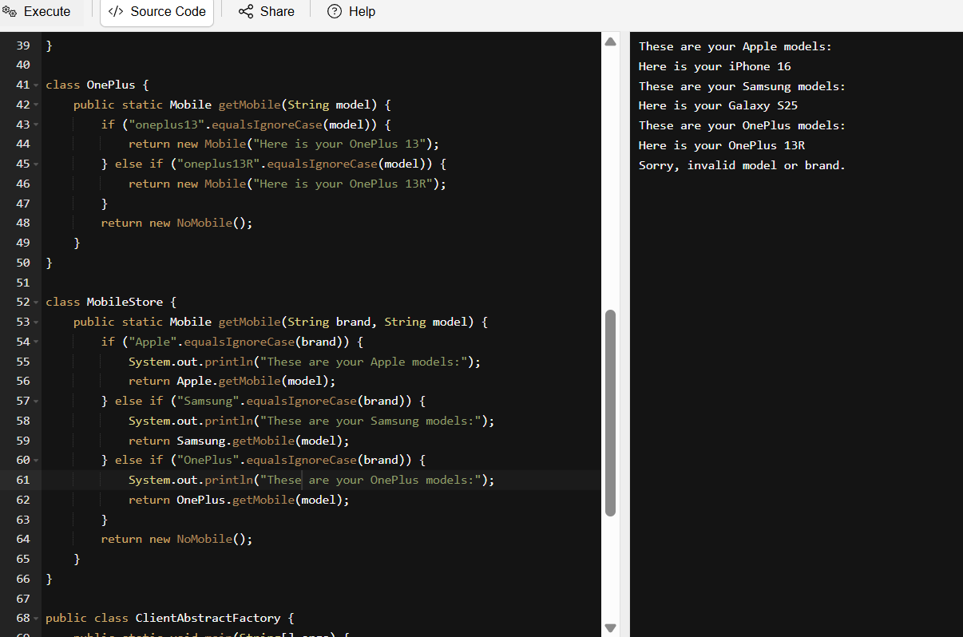
class Mobile {
String desc;

public Mobile(String model) {
this.desc = model;
}

public void getDesc() {
System.out.println(desc);
}
}

class NoMobile extends Mobile {
public NoMobile() {
super("Sorry, invalid model or brand.");
}
}

class Apple {
public static Mobile getMobile(String model) {
if ("iphone16".equalsIgnoreCase(model)) {
return new Mobile("Here is your iPhone 16");
} else if ("iphone16MaxPro".equalsIgnoreCase(model)) {
return new Mobile("Here is your iPhone 16 Max Pro");
}
return new NoMobile();
}
}

class Samsung {
public static Mobile getMobile(String model) {
if ("galaxyS24".equalsIgnoreCase(model)) {
return new Mobile("Here is your Galaxy S24");
} else if ("galaxyS25".equalsIgnoreCase(model)) {
return new Mobile("Here is your Galaxy S25");
}
return new NoMobile();
}
}

class OnePlus {
public static Mobile getMobile(String model) {
if ("oneplus13".equalsIgnoreCase(model)) {
return new Mobile("Here is your OnePlus 13");
} else if ("oneplus13R".equalsIgnoreCase(model)) {
return new Mobile("Here is your OnePlus 13R");
}
return new NoMobile();
}
}

class MobileStore {
public static Mobile getMobile(String brand, String model) {
if ("Apple".equalsIgnoreCase(brand)) {
System.out.println("These are your Apple models:");
return Apple.getMobile(model);
} else if ("Samsung".equalsIgnoreCase(brand)) {
System.out.println("These are your Samsung models:");
return Samsung.getMobile(model);
} else if ("OnePlus".equalsIgnoreCase(brand)) {
System.out.println("These are your OnePlus models:");
return OnePlus.getMobile(model);
}
return new NoMobile();
}
}

public class ClientAbstractFactory {
public static void main(String[] args) {
Mobile m1 = MobileStore.getMobile("Apple", "iphone16");
m1.getDesc();

Mobile m2 = MobileStore.getMobile("Samsung", "galaxyS25");
m2.getDesc();

Mobile m3 = MobileStore.getMobile("OnePlus", "oneplus13R");
m3.getDesc();

Mobile m4 = MobileStore.getMobile("Nokia", "3310");
m4.getDesc();
}
}

TASK:2 - Builder Method Design Pattern
// Product Component
class Laptop {
private int memory;
private int storage;
public Laptop() {
}

// Getters and Setters
public int getMemory() {
return memory;
}

public void setMemory(int memory) {
this.memory = memory;
}

public int getStorage() {
return storage;
}

public void setStorage(int storage) {
this.storage = storage;
}

@Override
public String toString() {
return "Laptop [Memory=" + memory + "GB, Storage=" + storage + "GB]";
}
}

// Builder Interface
interface LaptopBuilder {
LaptopBuilder buildMemory(int memory);
LaptopBuilder buildStorage(int storage);
Laptop build();
}

// Concrete Builder
class LaptopConcreteBuilder implements LaptopBuilder {
private Laptop laptop;

public LaptopConcreteBuilder() {
this.laptop = new Laptop();
}

@Override
public LaptopBuilder buildMemory(int memory) {
laptop.setMemory(memory);
return this;
}

@Override
public LaptopBuilder buildStorage(int storage) {
laptop.setStorage(storage);
return this;
}

@Override
public Laptop build() {
return laptop;
}
}

// Director (Not Neccesarily)
class LaptopDirector {
private LaptopBuilder laptopBuilder;

public LaptopDirector(LaptopBuilder laptopBuilder) {
this.laptopBuilder = laptopBuilder;
}

public Laptop constructLaptop() {
return laptopBuilder
.buildMemory(16)
.buildStorage(512)
.build();
}
}

// Client
public class ClientBuildMethodDP {
public static void main(String[] args) {
LaptopBuilder builder = new LaptopConcreteBuilder();
LaptopDirector director = new LaptopDirector(builder);
Laptop laptop = director.constructLaptop();

System.out.println(laptop);
}
}

Task:3 – Tried code.
package com.example;
//Prototype interface
public interface Colors {
Colors clone();
String getName();
void setName(String name);
}
package com.example;
public class BlackConcreteprototype implements Colors{
private String name;
public BlackConcreteprototype() {
System.out.println(" BlackConcreteprototype constructor is called");
}
public BlackConcreteprototype(String name) {
this.name = name;
}
public Colors clone() {
return new BlackConcreteprototype(this.name);
}
public String getName() {
return name;
}
public void setName(String name){
this.name = name;
}
}
package com.example;
public class WhiteConcretePrototype implements Colors{
private String name;
public WhiteConcretePrototype() {
System.out.println(" WhiteConcretePrototype constructor is called");
}
public WhiteConcretePrototype(String name) {
this.name = name;
}
public Colors clone() {
return new WhiteConcretePrototype(this.name);
}
public String getName() {
return name;
}
public void setName(String name){
this.name = name;
}
}
package com.example;
// client code of Prototype method Design pattern
public class Main {
public static void main(String[] args) {
Colors BlackPrototypeObj = new BlackConcreteprototype("Black Color");
Colors WhitePrototypeObj = new WhiteConcretePrototype("white color");
Colors clonedBlackObj = BlackPrototypeObj.clone();
Colors clonedWhiteObj = WhitePrototypeObj.clone();
clonedBlackObj.setName("dark color");
clonedWhiteObj.setName("light color");
System.out.println("black color is " + clonedBlackObj.getName());
System.out.println("while color is "+ clonedWhiteObj.getName());
}
}

Prototype Method Design pattern
prototype interface -- Colors
Concrete prototype --- class
WhiteConcretePrototype
constructor()
constructor(String...)
clone()
BlackConcreteprototype
client code

Home Task:1 - Develop the below prototype method DP
// Prototype Design Pattern - Integrated Implementation

interface Plant extends Cloneable {
Plant grow(); // Prototype method
}

// Concrete Prototype 1
class Creeper implements Plant {
private String growthType;

public Creeper(String growthType) {
this.growthType = growthType;
}

public String getGrowthType() {
return growthType;
}

public void setGrowthType(String growthType) {
this.growthType = growthType;
}

@Override
public Plant grow() {
try {
return (Plant) this.clone();
} catch (CloneNotSupportedException e) {
throw new RuntimeException("Creeper cloning failed", e);
}
}

@Override
public String toString() {
return "Creeper [growthType=" + growthType + "]";
}

@Override
protected Object clone() throws CloneNotSupportedException {
return new Creeper(this.growthType);
}
}

// Concrete Prototype 2
class Shrub implements Plant {
private String growthType;

public Shrub(String growthType) {
this.growthType = growthType;
}

public String getGrowthType() {
return growthType;
}

public void setGrowthType(String growthType) {
this.growthType = growthType;
}

@Override
public Plant grow() {
try {
return (Plant) this.clone();
} catch (CloneNotSupportedException e) {
throw new RuntimeException("Shrub cloning failed", e);
}
}

@Override
public String toString() {
return "Shrub [growthType=" + growthType + "]";
}

@Override
protected Object clone() throws CloneNotSupportedException {
return new Shrub(this.growthType);
}
}

// Client Code
public class PrototypeClient {
public static void main(String[] args) {
// Original objects
Plant creeper = new Creeper("Climbing");
Plant shrub = new Shrub("Bushy");

// Cloning using prototype
Plant clonedCreeper = creeper.grow();
Plant clonedShrub = shrub.grow();

// Output
System.out.println("Original Creeper: " + creeper);
System.out.println("Cloned Creeper: " + clonedCreeper);

System.out.println("Original Shrub: " + shrub);
System.out.println("Cloned Shrub: " + clonedShrub);
}
}

